IVY TECH COMMUNITY COLLEGE
SDEV 220 Python Programming
Chapter 9

YOUR NAME: ______________________________________________________________________

TO START YOUR PROGRAM
At the top of each of your Python programs, you should have four lines of documentation:
Program name (the Python file name), Author (your name), Date last updated, and Purpose (a brief description of what the program accomplishes). Here is an example:
# Program name: TemperatureConverter.py
# Author: Carl LaFong
# Date last updated: 5/16/2012
# Purpose: Print out your name, address, phone #, and college major

Leave a blank line and then begin to write your program

ASSIGNMENT: Programming Exercises #1 on page 415, and #6 on page 417, with the specifications listed below.
- Programming Exercise #1 (Course Information):
  - Name your Python program CourseInfo.py
  - Your program should have a main function that asks the user for the course number, then displays the room number, instructor and meeting time. If the course number is not found in any of the dictionaries, an error message is displayed. (You may have separate error messages for each dictionary.)
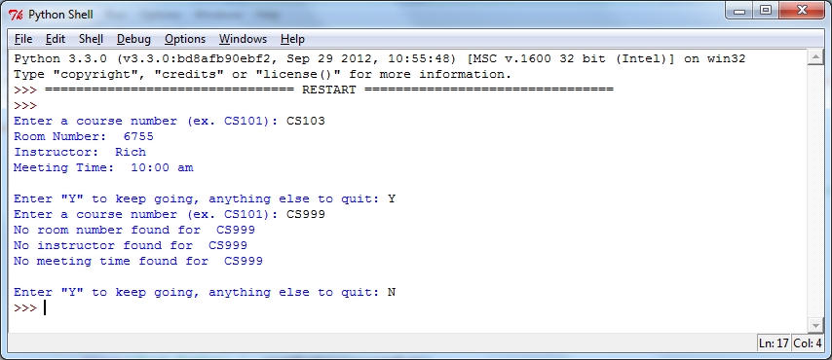
  - The program should loop so that the user can continue requesting information on course numbers until the user chooses to quit. .Above is a sample of what your program interaction might look like. Yours does not have to work exactly like this, as long as it works correctly.
  - Be sure to include the four lines of documentation at the top of each program, and a short comment above every line or small section of Python code.
- Programming Exercise #6 (File Analysis):
  - Name your Python file FileAnalysis.py
  - There are two text files provided with this lab assignment, textFile1.txt and textFile2.txt. The files contain one word per line.
  - Hint: Read these lines into lists, and strip off the newline character at the end of each one, then read the words from the list into sets.
  - The first two lines of display should contain the words in each set.
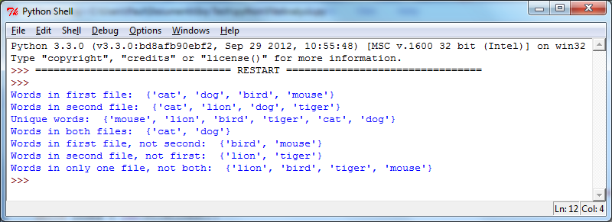
  - Here is a sample of what your program execution might look like. Yours does not have to look exactly like this, as long as it works correctly.
  - Be sure to include the four lines of documentation at the top of each program, and a short comment above every line or small section of Python code.

HOW TO SUBMIT YOUR ASSIGNMENT
Save and close your Python files. In Blackboard, go to the Class Session where this assignment is posted, attach your Python file(s), (Example: jcSalesPrediction.py) and submit for grading. For this assignment, you should submit two program files. You do not need to send the textfiles

